clc; clear; close all;
%% Parameters
N = 100; % Number of bits
sps = 20; % Samples per symbol
SNR = 10; % Signal-to-Noise Ratio (dB)
%% Generate Random Binary Data data = randi([0 1],1,N);
%% NRZ Encoding (0 -> 0, 1 -> 1)
tx_signal = repelem(data,sps);
%% Pass Signal through AWGN Channel rx_signal = awgn(tx_signal,SNR,'measured');
%% Time Axis

t = (0:length(tx_signal)-1)/sps;
%% Plot Results figure;
% Original Binary Data subplot(4,1,1) stairs(data,'LineWidth',1.5) grid on
title('Original Binary Data') xlabel('Bit Number') ylabel('Bit')
ylim([-0.2 1.2])
% Transmitted NRZ Signal subplot(4,1,2) plot(t,tx_signal,'LineWidth',1.5) grid on
title('Transmitted NRZ Signal') xlabel('Time') ylabel('Amplitude')
ylim([-0.5 1.5])
% Received Signal after AWGN subplot(4,1,3) plot(t,rx_signal,'r')
grid on
title(['Received Signal with AWGN (SNR = ',num2str(SNR),' dB)']) xlabel('Time')
ylabel('Amplitude')
% Eye Diagram subplot(4,1,4)

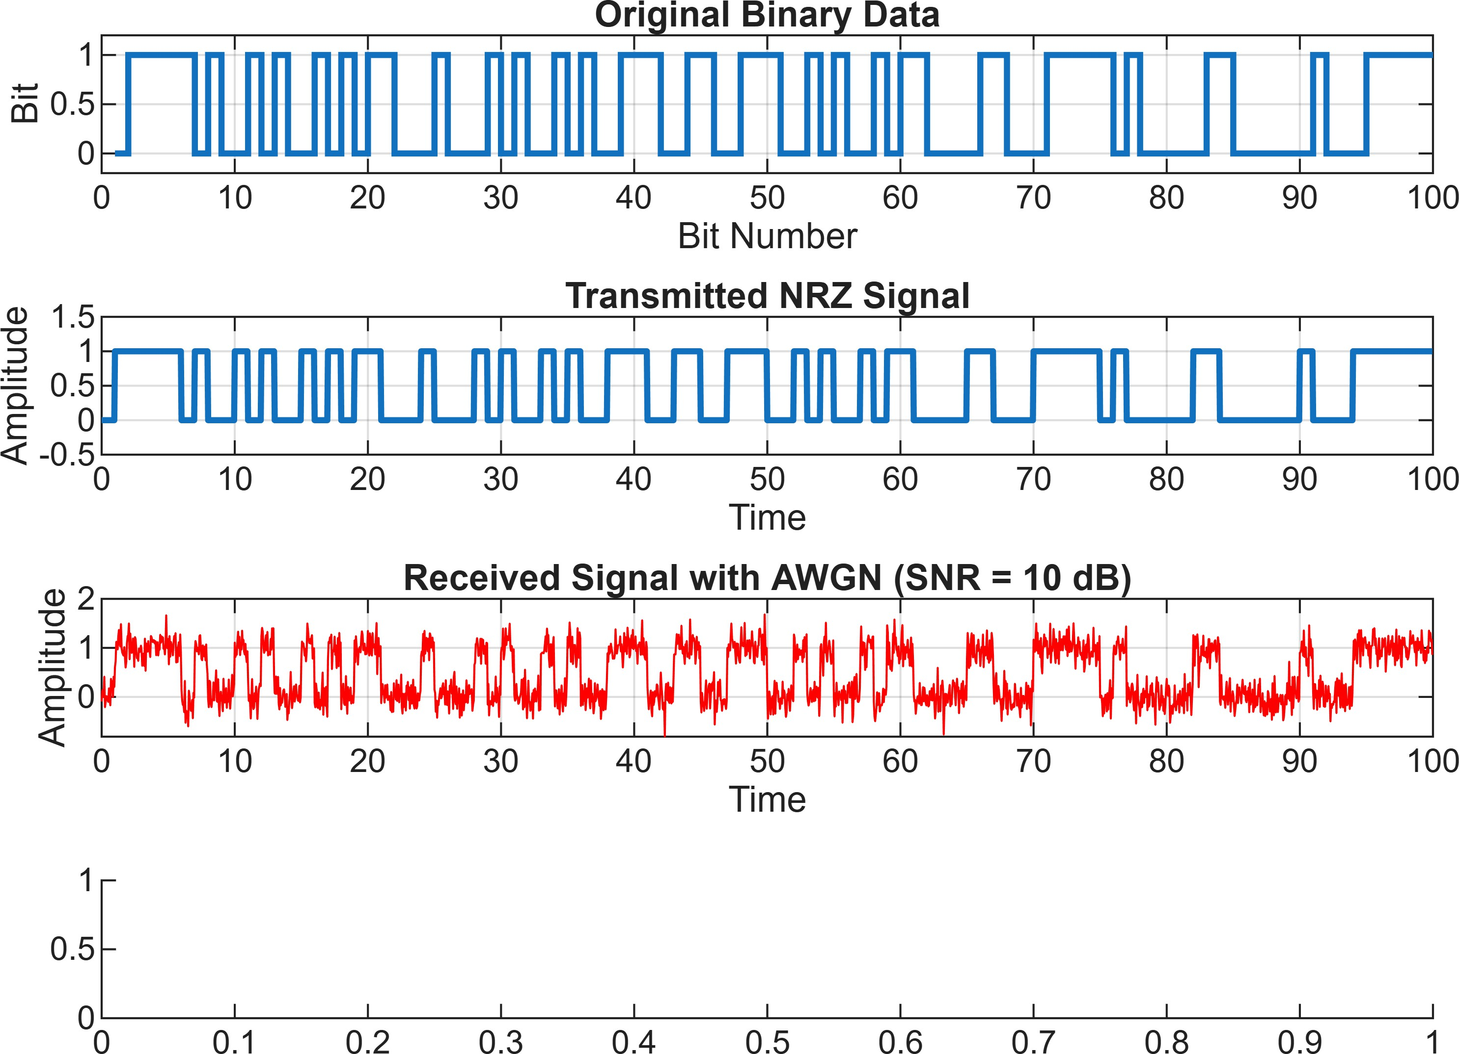

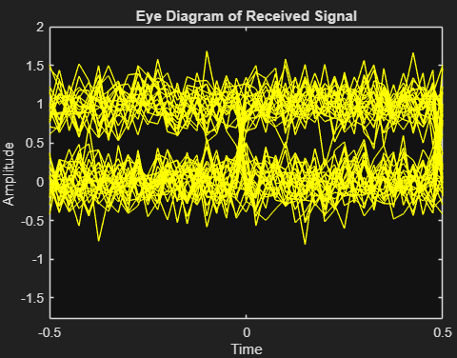
eyediagram(rx_signal,2*sps)
title('Eye Diagram of Received Signal')

